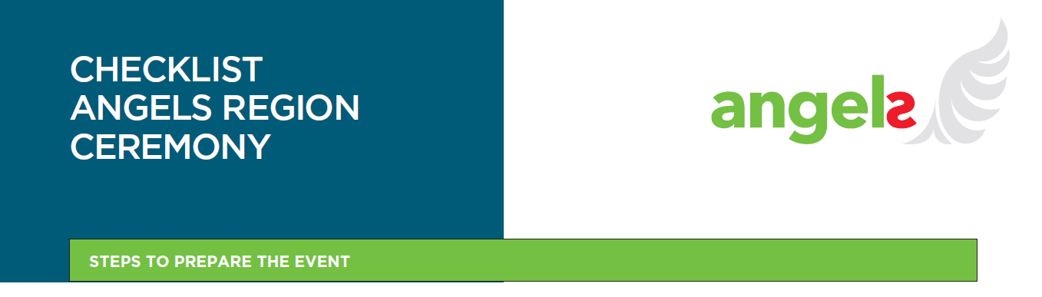

**Preparation Phase (1-2 Months Before the Event)**

|  |  |  |
| --- | --- | --- |
| **Contact the right persons:** | | |
|  | Start organizing as soon as the region is approved as Angels region. |
|  | Contact the Government Representatives directly or reach out to your neurologists/ hospital coordinator who have the connections with government representatives. |
|  | Involve government representatives to highlight the event's importance and attract press coverage. |
|  | Discuss ideas for the date, location, invitees, and agenda. |
|  | Inform the involved hospitals, EMS teams and FAST Heroes agency about the celebration and consider who to invite:   * *Hospital: Neurologists & others who are part of the achievement from the hospital* * *EMS teams* * *Ministries* * *Mayors* * *Patient associations & evtl a patient.* * *FAST Heroes representative & teachers* |
| **Budget Management:** | | |
|  | Try to stay low with the cost. |
|  | Approx. needed budget: *estimated max 5000 EUR (according to previous events)* |
|  | Be prepared for unexpected costs. |
|  |  |
| **Confirm Venue:** | | |
|  | Secure a venue using your network (e.g. city halls, theaters, auditoriums, or hospital meeting space) *!consider the local BI rules* |
|  | You may want to consider that the location is close to the school where you invite the FAST Heroes students for convenience. |
|  |  |
| **Coordinate with Fast Heroes Agency (students to join the event):** | | |
|  | Ensure collaboration: depending on the agency they may charge a fee since its outside of the global budget. Make them aware that they are part of the team and they have the same goal. In the best case they should not charge any fee for the arrangement. |
|  | Coordinate with the FAST Heroes Agency to involve 20-40 students. |
|  | Consider covering transfer and accommodation for FH representative. |
|  | Consider providing a school bus for student transportation (evtl. School bus from the school) |
|  | Decide which students from which school can attend the event & how many. |
|  | Decide who takes care of producing FAST t-shirts & masks. |
|  | *Idea: Provide special picnic bags with child friendly snacks and a drink (to avoid any dietary restrictions and make it a bit special for them)* |
|  | *Idea: Evtl to have a certificate for each student to hand over on the stage* |
|  |  |
| **Send Invitations:** | | |
|  | Send "Save the Date" or invitations to all parties involved with the agenda *(template available).* |
|  | Manageconfirmations and estimate headcount for *catering* and seating. |
| ***Optional - Arrange Catering:*** | | |
|  | Confirm catering (welcome coffee, snacks, etc.) and accommodate dietary restrictions (have a variety). -> consider that catering gives the space for networking. |
| ***Optional - Book Photographer/Video Recording:*** | | |
|  | Confirm and brief the photographer (budget: ~ 300-700 EUR) -> consider that this material can be used to influence in future meetings (SC meetings, FAST Heroes agency for teachers…) |
|  |  |
| **Prepare Printings:** | | |
|  | Print Angels Regions materials *(costs from previous events: ~1300 EUR).* |
|  | Contact CTL at least 3 weeks in advance for translations (if not translated yet) |
|  | Prepare reserved seat signs for speakers and government representatives in the front and for the students in the back. |
|  |  |
| **Plan AV Setup:** | | |
|  | Coordinate AV equipment needs with the venue (microphones, sound system, projector, screen). |
|  |  |
| **2-4 Weeks Before the Event** | | |
| **Confirm Participants:** | | |
|  | Finalize the list of attendees and manage RSVPs. |
|  | Ensure all participants feel part of the team. |
|  | Print the sign in sheet & the sign of Filming & Photography consent |
| **Speakers Briefing:** | | |
|  | Check in with speakers and offer support with their speeches. Make them aware that the focus is on celebration and not to have a scientific speech. |
|  | Schedule a rehearsal call if needed. |
|  | Optional: Prepare slides if relevant. |
| **Finalize Agenda & Timetable:** | | |
|  | Review and confirm the final agenda and event timeline. |
|  |  |
| **1 Week Before the Event** | | |
| **Send Reminder Emails:** | | |
|  | Send reminder emails to all participants with the final agenda attached. | |
|  |  | |
| **Venue Setup Planning:** | | |
|  | Finalize seating arrangements and AV setup. | |
|  |  | |
| ***Catering Confirmation (Optional):*** | | |
|  | *Confirm final numbers and dietary restrictions with the caterer (according to their deadline).* | |
|  |  | |
| **Logistics Check:** | | |
|  | Ensure all logistical details are in place (transportation, accommodation, etc.). | |
|  |  |
| **Day Before/Day of the Event** | | |
| **Venue Setup:** | | |
|  | Set up the venue with seating, AV equipment, branding, reserved seats, catering, and decorations. |
|  | Place the sign-in sheet at the entrance and ensure that it will get signed by each attendee. Pin the 'Notice of Filming and Photography' next to the door. |
| AV Rehearsal: | | |
|  | Conduct a final rehearsal to ensure AV equipment is working properly. |
| **Post-Event** | | |
|  | Send Thank You Email with pictures/ video from the event *(template available)* |
|  | Upload all pictures & videos for future use to: *<https://catherineturnerlimited.sharepoint.com/:f:/r/sites/AngelsEventActivityCalendar2022/Shared%20Documents/General/100%20regions%20ceremonies?csf=1&web=1&e=qRIccF>*  *[Compile Event Report](https://catherineturnerlimited.sharepoint.com/:f:/r/sites/AngelsEventActivityCalendar2022/Shared%20Documents/General/100%20regions%20ceremonies?csf=1&web=1&e=qRIccF)* |
|  | Document the event's success and areas for improvement. |
|  | Inform Annelize to write a story and make sure an article is written for the press. |

**Overview of available templates & files under Consultant Resource Page:**

* Invitation e-mail
* Invitation Flyer / Safe the date
* Agenda draft
* Printing materials
  + printing instructions,
  + ceremony certificates for EMS, hospitals and schools
  + photo wall to take pictures,
  + pull-up banners,
  + posters
  + pamphlets/flyers,
  + FAST Heroes T-shirt & mask
  + *optional: certificates for the students, EMS badge (textile piece to be ironed in the EMS uniforms)*
* Thank you e-mail

Feel free to reach out to us in case of any questions at angelscoreteam@iqvia.com